1. Project Title: Interactive Analytics Dashboard for Global Income Distribution
2. Project Statement and Outcomes:
The Interactive Analytics Dashboard for Global Income Distribution project aims to develop an interactive Power BI dashboard that visualizes income inequality data across various countries and regions. This project involves collecting, preprocessing, and structuring global income distribution and economic data to enable effective visualization. The dashboard will provide users with insights into income disparities over time, country-wise comparisons, and patterns of inequality globally.
The outcome will be a user-friendly dashboard, embedded within a Streamlit web application, offering an intuitive interface for economists, researchers, policymakers, and the general public. This platform will help users explore global income inequality, understand disparities across different regions, and analyze trends in wealth distribution. The project will conclude with comprehensive testing to ensure dashboard accuracy and usability, supported by detailed documentation for future reference and enhancements.

3. Modules to be Implemented:
- Data Collection and Preprocessing
- Data Structuring, Transformation, and Power BI Dashboard Development
- Exploring and Streamlit Integration
- Testing, Review, and Documentation
4. Week-wise Module Implementation and High-Level Requirements:
Weeks 1-2: Data Collection and Preprocessing
- Collect global income inequality data from sources like World Bank, OECD, IMF, and income distribution datasets.
- Gather related economic indicators such as Gini Index, income share by decile, median income, and GDP per capita.
- Clean and preprocess data to handle missing values, discrepancies, and regional variations.
- Ensure the dataset is representative of different countries, income groups, and time periods.
Weeks 3-4: Data Structuring, Transformation, and Power BI Dashboard Development:
- Structure data into a standardized format for visualization.
- Perform data transformations like normalization, aggregation, and calculation of inequality metrics.
- Design the layout of the Power BI dashboard with global comparisons, region-wise trends, and income distribution visualizations.
- Develop visualizations that highlight income gaps, country-level inequality, and changes over time.
- Add filters, slicers, and interactive elements to allow customized exploration.
- Ensure the dashboard is visually appealing and user-friendly.

Weeks 5-6: Exploring and Streamlit Integration
- Explore Streamlit framework for hosting dashboards.
- Develop a Streamlit web application to host the Power BI dashboard.
- Embed the dashboard into Streamlit using an iframe within an HTML tab.
- Ensure the Streamlit app allows seamless user interaction with the dashboard.

Weeks 7-8: Testing, Review, and Documentation
- Perform extensive testing of the dashboard to ensure accuracy, functionality, and user experience.
- Review and refine the visualizations to enhance their clarity and effectiveness.
- Test the Streamlit application to ensure the embedded Power BI dashboard functions correctly.
- Document the entire process, including data collection methods, preprocessing steps, and dashboard features.
- Prepare the final report and presentation, detailing the insights provided by the dashboard and its potential applications in tourism strategy and planning.

5. Flow chart:

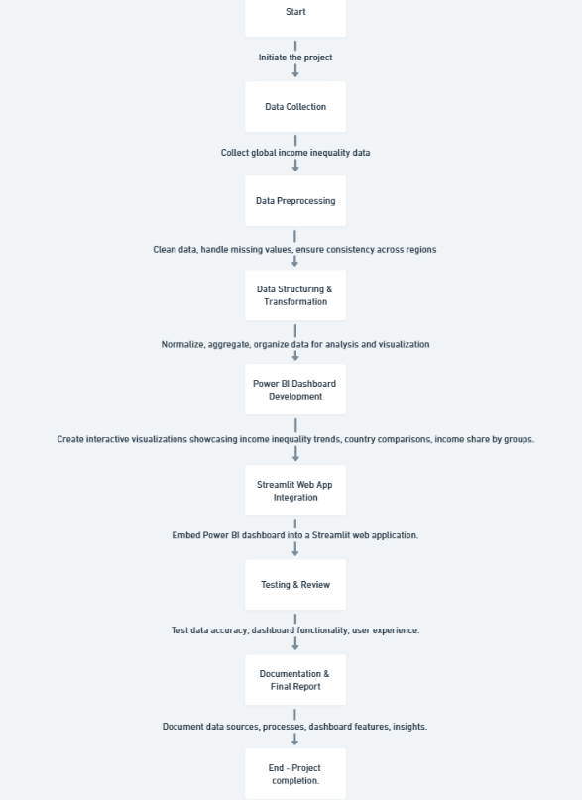
6. Sample Dashboard:
